Downham Market Town Hall
Fire and Emergency Procedure for lettings
The person organising the lettings is responsible for fire safety in absence of the caretaker. This forms part of the letting’s agreement. You are responsible for the emergency actions
Please read this document and check the fire procedure on the notice board in the lobby
- Make sure electric appliances are in good order, cables are used safely, extension leads are used safely (not connected into each other) and power points are not overloaded.
- Hirers must ensure their portable appliances are PAT tested
- Hirers must not use portable heater without the approval of the caretaker
- You are not permitted to complete hot work, use fireworks or pyrotechnics – including anything that has a naked flame- without a fire risk assessment being completed beforehand and approved by the Town Clerk
- On arrival make yourself familiar with the layout of the building, the fire exits and the fire safety notices and fire alarm on the notice board in the lobby
- Make sure that any disabled person’s carer is aware of emergency procedures for their charge
- If you discover a fire raise the alarm using a call point.
- On hearing the alarm ensure everyone leaves the building by the nearest exit and goes to the car park. Do not use the lifts
- Do not stop to collect personal belongings
- If the alarm sounds, the person in charge will dial 999 and state:
“There is a fire at Downham Market Town Hall, Bridge Street,
Downham Market, Norfolk, PE38 9JS”
Call the caretaker – the number is in the lobby. The duty officer will assist you and the Fire Service
- If it is safe to do so, check all the rooms you have used. Check the toilets.
- Check everyone is safe and has left the building. If anyone is missing you must tell the fire service as soon as they arrive
- Meet the fire service and tell them what has happened.
- Wait for instructions from the fire officer in charge.
- Do not allow anyone to return to the building until advised to do so by the fire officer in charge
- If you suspect a gas leak. Turn off the appliance, open doors, do not operate electrical equipment, evacuate the building but avoid panic and tell the emergency services

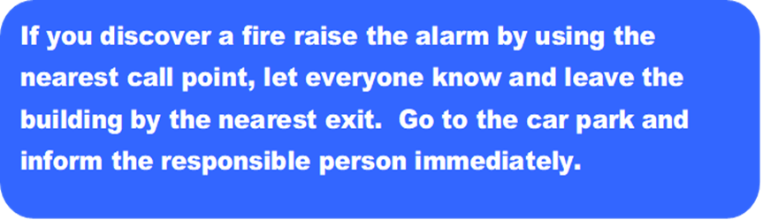

In the event of a fire a siren will sound. Leave the building by the nearest exit, make sure other also leave, go to the car park and wait for instructions
The caretaker or person in charge will call the fire service by dialling 999 and state:
“Fire at Downham Market Town Hall, Bridge Street, Downham Market, Norfolk, PE38 9JS”
and give them your phone number
If it is safe to do check all rooms, toilets and the wheelchair refuge on the first floor. Do not take risks. Check everyone else is safe.

Regular users will be asked to read and confirm their understanding every year.
I agree that I have read and understand the Downham Market Town Hall’s Fire and Evacuation Instructions and that I am responsible for the emergency actions in the absence of the caretaker.
Signed:
Please Print Name: Date:

