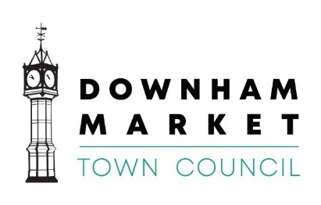
15 Paradise Road, Downham Market, Norfolk PE38 9HS
Tel: (01366) 387770 E-Mail: info@downhammarkettc.co.uk
Town Clerk: Graham Spark

You are invited to a meeting of the Human Resources Committee which will be held on
Tuesday 10th May 2022 at 2.00pm to discuss the business on the agenda below.
The meeting will be held at the Town Council Offices, 15 Paradise Road, Downham Market, Norfolk PE38 9HS.

Yours faithfully

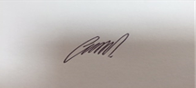

Graham Spark
Town Clerk
4th May 2022

Mobile phones should be either switched off or on silent mode.
SELFLESSNESS, INTEGRITY, OBJECTIVITY, ACCOUNTABILITY, OPENESS, HONESTY & LEADERSHIP

Agenda

1 | To receive Members’ apologies for absence
2 | To receive Members’ Declarations of interest
3 | To approve the minutes of the meeting on 26th April 2022
4 | Confidential Items to be discussed under:  Standing Order 3d, that in view of the confidential nature of the business about to be transacted, it is advisable in the public interest, that the public and/or the press be temporarily excluded, and they are instructed to withdraw  4.1 To discuss staffing matters
5 | To review and amend if required Deputy Town Clerk and Administration Assistant Job descriptions.
6 | To receive an update on the appointment of a Maintenance Officer
7 | To agree the date of the next meeting

