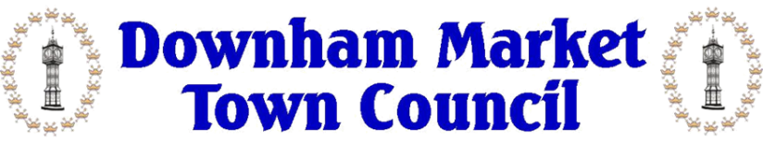

working in partnership with
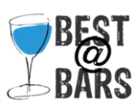 and
Best&Bars -

Downham Market Town Council works in partnership with Best@Bars who are the sole bar provider for Downham Market Town Hall

If you wish to have a licenced bar, please contact Best@Bars directly, using the following contact details: Mobile: 07469876850 Email: bestatbars@gmail.com Website: www.bestatbars.com

Please note this policy is applicable to all events that Downham Market Town Hall is hired for and that Best@Bars is the only contracted supplier. It is important therefore for you to contact Best@Bars as soon as possible after confirming your booking.

Please be aware to ensure compliance with the licensing regulations this policy applies to the provision of all alcohol and not just that sold.

Under no circumstances shall alcohol be sold to or consumed by persons under 18 years of age. Photographic identification may be required.

The Town Council’s premises license WNPL/00/5298 stipulates that alcohol should not be sold on the premises before 10:00am Monday – Sunday.

The Town Council does not permit alcohol to be consumed outside of the premises. Anyone found consuming alcohol out of the designated areas may be removed from the premises.

Security

Your event may require security due to the risk to you of external parties entering your event uninvited. Please speak to a member of the office staff at Downham Market Town Council for more information.

You are required to book trained security with the appropriate Public Liability Insurance. The Council will not arrange security for your event.

We have previously worked with Force8 security which meets the above requirement however you are free to pick your own provider.
Force8. Keystone Innovation Centre, Croxton Road, Thetford. Norfolk. IP24 1JD

Tel: 01842 764288

Email: info@force8team.co.uk

We require sight of the paid invoice and confirmation that the provider meets all legal requirements. If the Council do not receive the confirmation that security has been booked a minimum of 28 days before the event, then the Council will cancel the booking and no refunds or compensation will be due.

