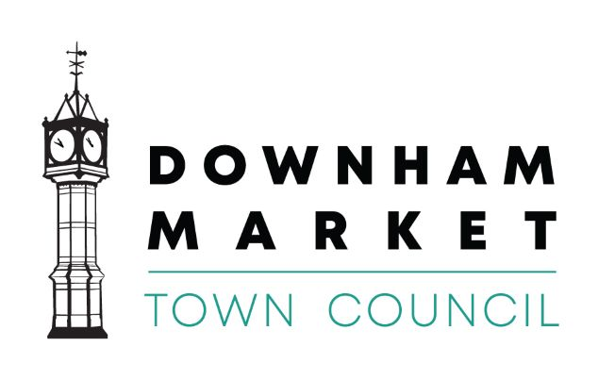
Downham Market Local Heroes Awards 2020
NOMINATION FORM
What is your name?
How can we contact you? | Email address:  Phone no.
Who do you wish to nominate for an award? | Name:
How can we contact them? | Email address:  Phone no.

Which award do you think they deserve to receive? See overleaf for categories

Please tell us why you think they deserve this award?

Continue on a separate page if necessary.

Two ways to nominate
You can complete the form and return it by post to Downham Market Town Council, 15 Paradise Road, Downham Market, PE38 9HS.
You can submit your nomination by email to info@downhammarkettc.co.uk. An email must contain the above information to be included.
Closing date for nominations is 5th April 2020
Nominations received after this date will not be considered.
Award categories
Young Volunteer of the Year - 17 years and under
Which young person in the community do you think deserves to be recognised for their voluntary contribution, helping to make their organisation or activity a success? Nominees must either live or go to school in Downham Market or volunteer in Downham Market.

Volunteer of the year - 18 years and over
Who in the community do you think deserves to be recognised for their voluntary contribution helping to make the organisation or activity a success? Nominees must either live, work or attend education in Downham Market or volunteer in Downham Market.

Young Carer of the Year– 17 years and under
Do you know a special young person in the community who has touched your life or the life of someone you know? This young person must live or go to school in Downham Market or care for an individual(s) in Downham Market.

Carer of the Year – 18 years and over
Do you know a special person in the community who has touched your life or the life of someone you know? This person must live, work or attend education in Downham Market or care for an individual(s) in Downham Market.

Local Charity of the Year
A charity which you think deserves nominating for their work within Downham Market and the contribution that they make to individuals who live within the town. The charity must either be based in Downham Market or work within Downham Market.

Environmental Award
An individual, business, school or group who has contributed to improving the environment in Downham Market.

Sports Club of the Year
Nominate your sports club, not only for their success but for their good management, safeguarding, friendliness and ability to attract individuals from all backgrounds. This club must be based in Downham Market.

Young Sports Person of the Year – 17 years and under
A young person who has excelled at their sport and demonstrated drive and determination whilst being a good role model to others. This individual must either live or go to school in Downham Market or belong to a club based in Downham Market.

Sports Person of the year – 18 years and over
Nominate an individual who has excelled beyond expectation within their sport demonstrating skills that inspire others and puts them at the top of their field. This individual must either live, work or attend education in Downham Market or belong to a club within Downham Market.

Overcoming adversity award
Who do you know that has been through a traumatic time in their life but has come out on top? They may have taught you a lesson in being thankful for what you have got and given you hope for the future. They may have gone on to support others and provide education and change attitudes. This person(s) could live, work or attend school in Downham Market.

Neighbour of the year
This award will recognise an incredible neighbour who has supported someone when times are tough. Maybe family are not nearby or maybe they do not have any close family to support them. Someone who looks in on them to say hello, does the shopping or just cares! This award is for anyone living in the Downham Market community.

