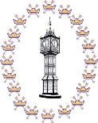

**Downham Market Town Hall Booking Form**

If you would like to request a quote or make a booking, please complete this form. An asterisk (*) denotes a mandatory field and enquiries may be delayed if this information is not provided.

Please note that bookings are not confirmed until we have received a completed booking form and the agreed deposit. All bookings are subject to our terms and conditions, Bar application procedures and GDPR privacy policy which we recommend you read carefully.

If you would like further information before requesting a quote or booking, please contact Downham Market Town Council on 01366 387770, [info@downhammarkettc.co.uk](mailto:info@downhammarkettc.co.uk) or by visiting the Council Offices at 15 Paradise Road, Downham Market, PE38 9HS.

**About You**

*Organisation/Business/Hirers Name:

Invoicing

address:

*(if different)*

*Your address:

*Post code:

*Post code:

*Email address: 

Mobile No:

*Telephone No:

*Is your Organisation/Business/Group a registered charity?

NO

YES (Charity Number):

**About your event**

Event Name:

*Date(s):

*Arrival time:

*No. of attendees:

*End time:

*Start time:

Rental Price: (Office Use)

*Departure time:

Which room/s do you wish to book? Please tick:

Grand Hall

Clock Room

Assembly Room

Will kitchen be required? (Grand Hall only) Y/N

*Event Details: (Please include; Type of event,

If alcohol will be on premises, if it is a ticket selling

event etc.)

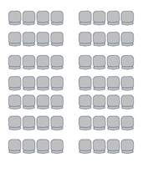

Meeting

Theatre

*Layout (please tick your required layout)

**Your room requirements**



Classroom

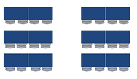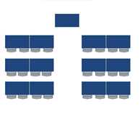

Boardroom

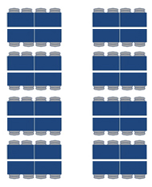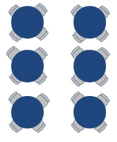

Cabaret

(Premier)

Cabaret

(Standard)

Other Layout

Please discuss with a member of the booking team: 01366 387770

**Your equipment requirements**

(Please tick all that apply)



Drapes 

Microphone

Flipchart

Hot Water Flasks

Projector

Tiered Seating

Modular Staging

Sound System

Round Tables /number 

Rectangle Tables/number 

Cups/Saucers/number 

Chairs /number 



The office will call you a week before your event to confirm your set up requirements 

**Your signature**

I certify that I have read, understood and agree to the ‘Terms and Conditions of Hire’, ‘Bar Provider Details’ and the ‘GDPR Policy’, copies of which have been found on the Town Council website or have been provided to me upon request.

*Print:

*Signature:

*Date:



**Downham Market Town Hall Prices & Capacity**

|  |  |
| --- | --- |
| **Grand Hall** (Capacity 280 people) | |
| **Per Hour** - £25.50  **Rehearsal/ Set Up** - £14.00  **All Day** - £240.00 | **Commercial Per Hour** - £31.00  **Commercial All Day** - £271.50 |

|  |
| --- |
| **Grand Hall plus Clock Room Prices** |
| **Per Hour** - £40.00  **All Day** - £373.50 |

|  |
| --- |
| **Grand Hall plus Clock Room and Assembly Room Prices** |
| **Per Hour** - £50.50  **All Day** - £480.50 |

|  |  |
| --- | --- |
| **Clock Room** (Capacity 52 people seated) | |
| **Per Hour** - £14.50  **All Day** - £133.00 | **Commercial Per Hour** - £17.50  **Commercial All Day** - £156.50 |

|  |  |
| --- | --- |
| **Assembly Room** (Capacity 70 people seated) | |
| **Per Hour** - £14.50  **All Day** - £133.00 | **Commercial Per Hour** - £17.50  **Commercial All Day** - £156.50 |

|  |  |
| --- | --- |
| **Equipment** | |
| **Grand Hall Projector** - £36.00  **Small Projector -** £21.00 | **Modular Tiered Seats** - £67.00  **Modular Stage** - £42.00 |

|  |
| --- |
| *For larger scale & ticket selling events door security, PRS and event plans may be required. Booking staff will discuss this with you.* |